Income Narrative 2023
We are a connectional church: whereas an individual congregation does ministry mostly in its own area, the presbytery is a group of churches working together for the good of all the churches, doing things that a single church cannot do, and providing oversight for all the churches in its area. We are Mission Presbytery.
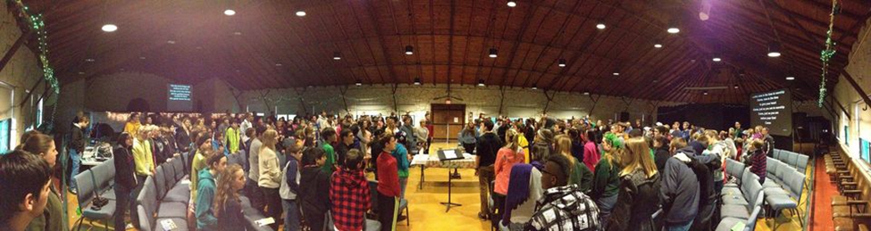
Panorama shot of Midwinter Gathering
The Book of Order states that the presbytery is “responsible for the government of the church throughout its district, and for assisting and supporting the witness of congregations to the sovereign activity of God in the world, so that all congregations become communities of faith, hope, love, and witness.”
This responsibility is accomplished mostly by numerous elders volunteering to work together in presbytery commissions, committees, and task forces. With a presbytery the size of Mission, we need someone whose job it is to know what is going on in all churches and committees of the presbytery - and we are thankful to have Sallie, who more than rises to this challenge. We are required to have a Stated Clerk and are thankful to have Laurie for much of the “decently and in good order” matters. With the vast amount of presbytery money and bills, we need an accountant and are thankful to have Jeanne. We need a magician to keep communication working and flowing in the office and we are thankful to have Melody. We are making an effort to bring the gospel to the RGV in a new way and are thankful for Ezequiel. We want to keep a special concern for youth (more on that later) and are thankful to have Caitlin and Henry and the JKR staff.
It would be very difficult for the elders to do their presbytery work without the dedication and support of our staff. Accordingly, we have a presbytery with a budget - and a big part of that budget goes toward salaries for that staff so that the presbytery can fulfill its ministry. They are like the tent poles that hold up the canvas of the tent – they allow the tent to do its job: to cover and protect a large swathe of land and the people under it. Here is the 2023 income projection, as a pie chart:

Imagine all our presbytery does, for example:
- employ great staff and have an office with supplies and equipment to support the work of our Elders;
- run a major Christian camp with ~1000 campers per year and available to all youth, emphasizing Reformed understanding of the Bible (how many Christian camps do that?);
- develop programs for youth throughout the presbytery;
- help us communicate with each other via meetings, the weekly newsletter, emails, and other venues;
- pay an evangelist for the RGV;
- issue grants totaling ~$100,000 annually for various mission and ministry efforts;
- care for all the churches, finding pastoral leadership for churches, assisting churches in need, providing low or zero-interest loans for churches so they can thrive;
- receive and determine the best uses for acquired property, whether it is for redevelopment of churches or to carry out the sale;
- carry out all the responsibilities stated in the Book of Order

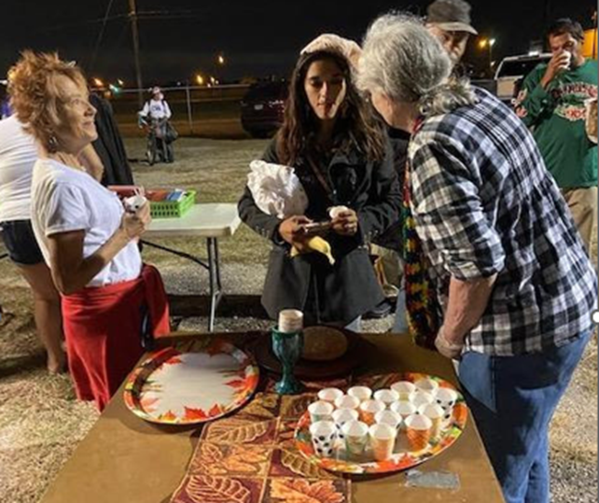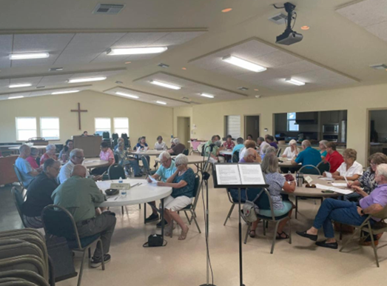
Serving the homeless in Corpus Christi Gathering at Canyon Lake
How much is this worth? If you had to start from scratch, it would be a lot. Please note that on the pie chart, the projected income needed for 2023 is ~$1.6 million. Also notice that the individual churches’ anticipated contribution is only $385,000 which is only 23% of the pie. How can we do this? With incredible leverage!
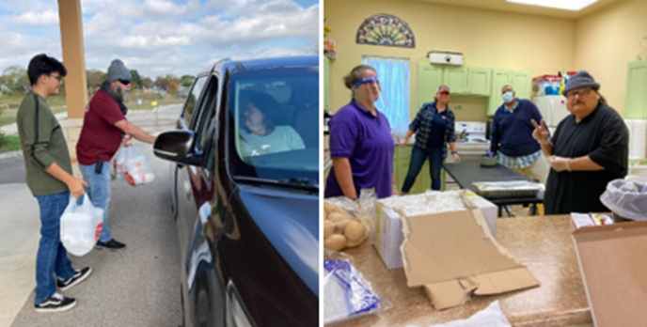
Delivering Thanksgiving meals in New Braunfels
The second category is “Interest/Designated Funds (14%).” The presbytery has money invested at the Texas Presbyterian Foundation (TPF) and a few other places, and these investments earn interest. At this time, the Presbytery has $5.3 million invested in various accounts at TPF. Thanks to this disciplined investing, we have reserves and can use interest to drive ministry. Designated funds are monies which are earmarked toward certain ministries and must be spent in narrowly defined ways. The designated funds originated from certain donations over the years, or as settlements from churches leaving the denomination.
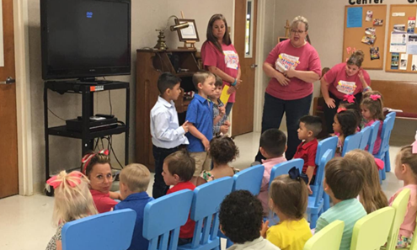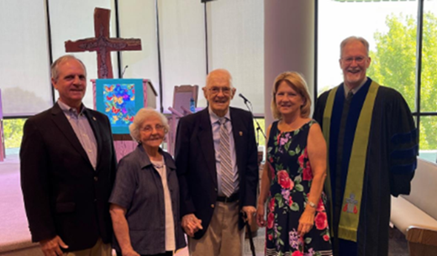
From young disciples………………...to celebrating 70 years of Ministry

The third category is “leases and principal payments (14%).” The presbytery owns “The Broadway Building” which not only houses the presbytery offices but also brings in rental income from other tenants. The presbytery also received payments from churches it has lent money – these are referred to as “principal payments.”
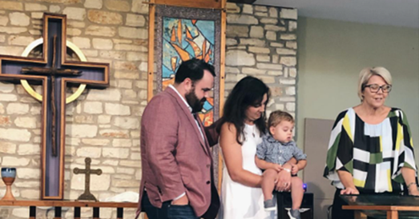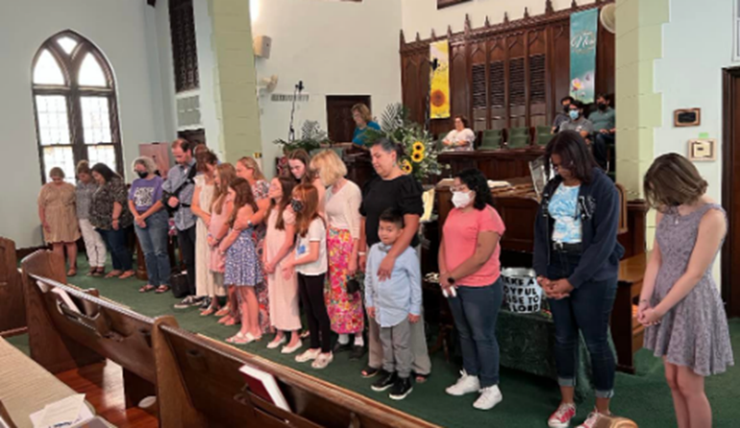
A baptism at Shepherd of the Hills Together at FPC Brownsville

The fourth category has to do with youth: John Knox Ranch and the activities of the Youth Connection Committee, which puts on Midwinters, Main Event, and Youth Triennium. Notice that this is about half the entire budget (49%), and almost entirely paid for with fees.
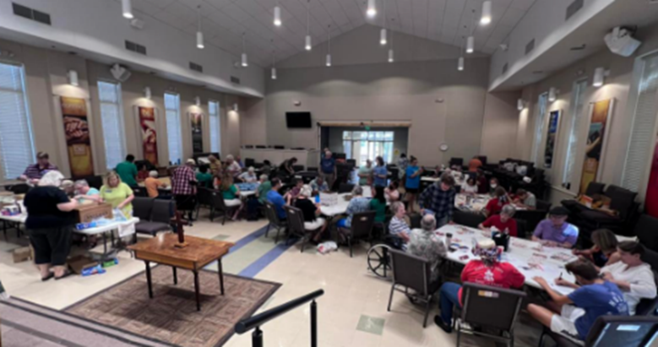
Grace PC in Round Rock held their annual “Be the Church Day” event

Now you might think, “This pays for itself and doesn’t need to be in the budget.” Suppose there were no JKR. Imagine a church wanted to have a camp with a thousand students. Sure, they could get registration money from people, maybe lots of people, but how will that be processed? Who will run the thing? Who will train the youth leaders, and where will you get them all? Who will develop the curriculum and activities? Where will they get the land to be on? Who will build the pool, the dining room, the showers, the sleeping areas? How will you feed them? How will the kids be kept safe with policies and procedures? Who will attend to the legal responsibilities? When you think about it, it is too daunting to imagine any church being able to pull this off, no matter how big it is.
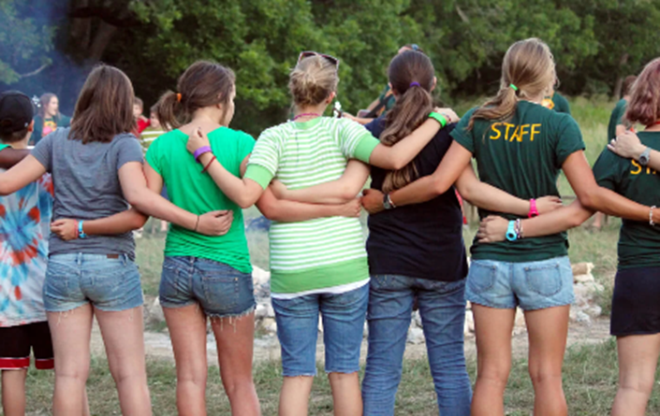
Happy campers at John Knox Ranch
Yes, even though the JKR camp is pretty much "revenue neutral" on paper with fees paying for yearly expenses, the camp would not exist without the presbytery's leadership (like Henry), the JKR Committee, the General Council, etc. It's hard to imagine with today's JKR success that not many years ago JKR was considered for possible sale -- and had it been sold, it would be impossible to rebuild what we have now. It takes the machinery and resources of the presbytery to keep it running.
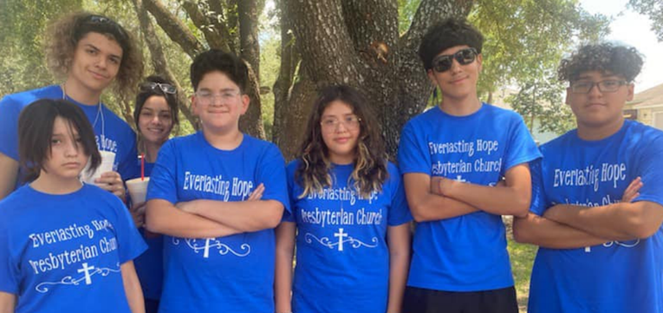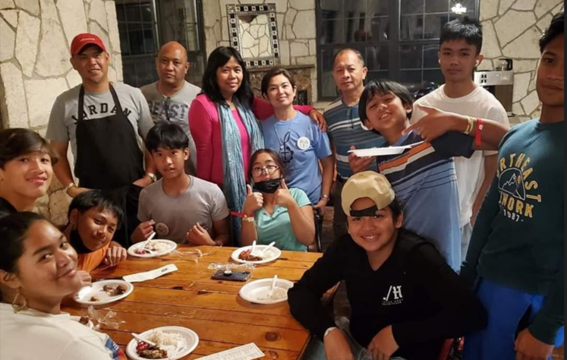
Youth in Taylor Youth in Corpus Christi

To a smaller degree, the same is true for YCC and events like Midwinters. Yes, it pays for a lot of its own costs through fees, but again it is the YCC, the leadership at the presbytery level, etc. that makes these events possible and probably beyond the reach of any particular church in the presbytery.
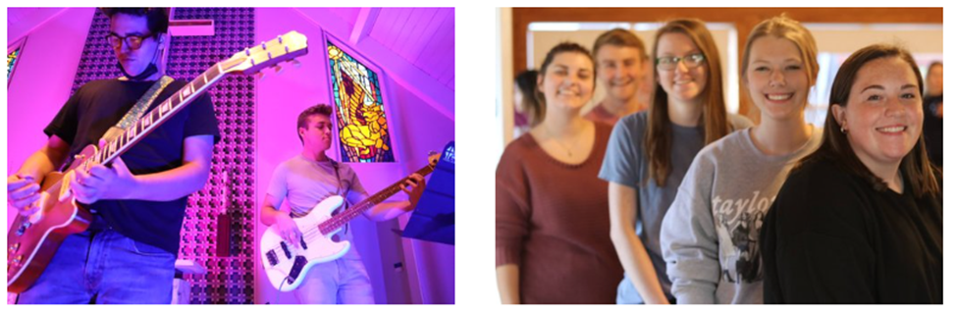
College Campus Ministries

In conclusion, you, the churches of Mission Presbytery, get (at least) $1.6 million worth of services for 2023 and only pay for $385,000 (23%) of it - due to generous giving in the past, careful investing of funds over the years, wise setting of fees, and maintaining some excellent property. And, yes, the presbytery could charge a fee - take that $385,000, divide it among the total number of members of our 120 churches, and send each church a “bill.” Most presbyteries do that. For years, Mission Presbytery has not done that, but instead has relied on the generosity of our member churches to give to Benevolence each year.
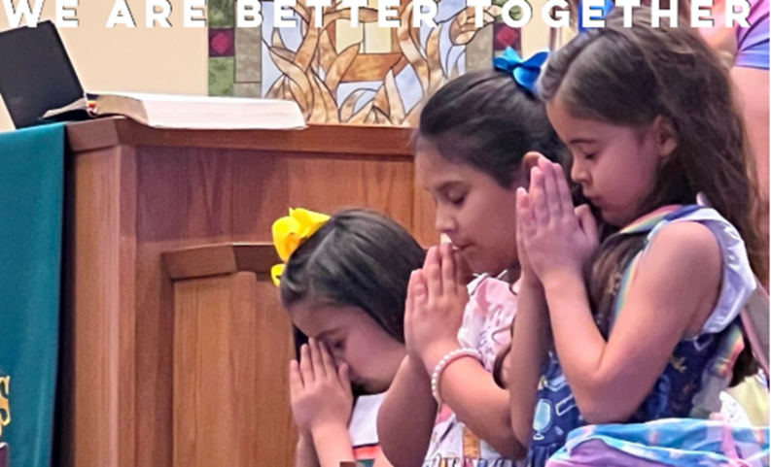
Prayer time at FPC New Braunfels 4 baptisms and 2 renewals at FPC Copperas Cove

We hope you will see by this Income Narrative how much we are getting for our money as churches - and how essential it is for ALL to give generously to keep engaging not only with our present ministries and responsibilities, but to imagine what we could do with more.
Grace and peace,
Michael Day and Eric Dittman, co-chairs, Fiscal Oversight Team
Kevin Jones, chair, Stewardship Team
(The Stewardship Team and the Fiscal Oversight Team are the two halves of the Stewardship and Fiscal Oversight Committee)

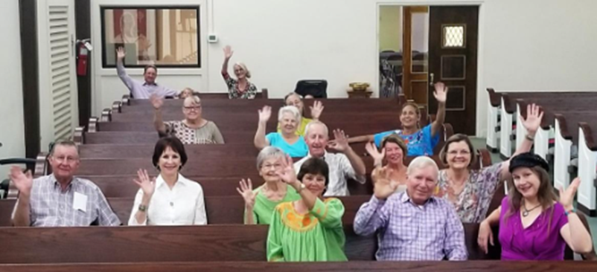
Greetings from FPC Uvalde

